**UBER AND LYFT RIDESHARE DATASET BOSTON**

Introduction

**Uber and Lyft Data Set**

**Project Idea:** Develop a transportation analytics and optimization system that uses historical ride data to enhance the efficiency and quality of transportation services in a specific region.

**Why Dataset & Project Interest:** The dataset contains detailed information about rides, including timestamp, location, weather conditions, and ride attributes. Leveraging this data can offer insights into ride patterns, factors affecting ride demand, and potential areas for service improvement. The project aims to provide better transportation services, reduce costs, and improve customer satisfaction.

**Major User Types**

* Riders: Users looking for transportation services.
* Drivers: Individuals providing transportation services.
* **Service Providers: Lyft, Uber, etc.**
* Data Analysts: Individuals analyzing and making decisions based on the dataset.

**How the App or Service is Used:**

**1.Data Analysts:**

**Use Case:** Demand Prediction

**Usage:** Analyzing historical ride data to predict future ride demand for different times and locations. This helps in strategic planning for resource allocation and service optimization.

**2.Drivers and Service Providers:**

**Use Case:** Route Optimization

**Usage:** Utilizing real-time analytics to optimize routes, reducing travel time and improving efficiency. This benefits both drivers and service providers by enhancing the overall transportation experience.

**3.Service Providers:**

**Use Case:** Dynamic Pricing

**Usage:** Implementing dynamic pricing strategies based on demand and weather conditions. This ensures that pricing is reflective of market demand, optimizing revenue for service providers.

**4.Riders:**

**Use Case:** Service Recommendations

**Usage:** Receiving personalized service recommendations based on user preferences and weather conditions. This enhances the rider's experience by providing tailored transportation options.

**App's Cost Model:**

The app operates on a freemium model:

**Free Tier:** Basic access to historical ride data and general transportation analytics.

**Premium Tier (Paid):** Access to advanced features such as real-time demand prediction, dynamic pricing strategies, and personalized service recommendations.

Users can subscribe to the premium tier on a subscription basis, allowing them to benefit from the full range of optimization and analytics features. The subscription fee contributes to the ongoing development and maintenance of the platform.

**Personal Connection:**

As a user, I chose this app because of its comprehensive approach to improving transportation services. The integration of historical ride data, real-time analytics, and optimization features ensures a seamless experience for both riders and drivers. The freemium model allows me to access basic transportation analytics for free, while the subscription provides added value through advanced features. The commitment to optimizing routes, predicting demand, and implementing dynamic pricing aligns with my desire for a reliable and efficient transportation service.

# Business Analysis

**Primary Use Cases & Personas:**

**1.Demand Prediction:** Predict ride demand for different times and locations.

**Persona: Data Analyst**

A data analyst working for a ride-sharing company plays a crucial role in demand prediction. Primary responsibility involves analyzing vast amounts of historical ride data to identify patterns and trends.

**2.Route Optimization:** Optimize routes for drivers to reduce travel time.

**Persona: Drivers**

A dedicated driver who relies on the ride-sharing platform for income. Route optimization is key to maximizing earnings and minimizing travel time. With the help of optimized routes suggested by the platform, drivers can efficiently navigate through traffic, reducing idle time and fuel costs.

**3.Dynamic Pricing:**Implement pricing strategies based on demand and weather conditions.

**Persona: Service Providers**

A service provider in charge of pricing strategies is focused on implementing dynamic pricing based on demand and weather conditions. His role involves analyzing real-time data to find peak hours, high-demand locations, and weather-related patterns.

**4.Service Recommendations:** Suggest service types based on user preferences and weather.

**Persona: Riders**

A regular rider on the platform, benefits from personalized service recommendations based on preferences and the current weather. The platform suggests different service types, considering such as past ride history, preferred vehicle types, and weather conditions. This persona emphasizes the importance of user-centric features that contribute to customer satisfaction and loyalty.

**Business Rules**

1. **Ride Request Acceptance:**
   * **Rule:** A driver can accept a ride request only if they are available and within a reasonable distance from the user's pickup location.
   * **Explanation: This rule ensures that drivers respond to ride requests only when they provide timely service to the user.**
2. **Pricing Calculation:**
   * **Rule:** The price for a ride is calculated based on factors such as distance, time, and any applicable surge multipliers.
   * **Explanation:** This rule defines the formula for determining the cost of a ride, providing transparency to users and ensuring consistent pricing logic.
3. **Weather Impact on Pricing:**
   * **Rule:** Surge pricing may be applied during adverse weather conditions, impacting the overall cost of a ride.
   * **Explanation:** This rule reflects a dynamic pricing strategy based on weather conditions, helping to manage demand during challenging weather scenarios.
4. **User Registration:**
   * **Rule:** Users must provide valid and complete information during the registration process, including accurate location details.
   * **Explanation:** Ensuring accurate user information is crucial for effective communication, location tracking, and providing a reliable transportation service.
5. **Driver Ratings:**
   * **Rule:** Users can rate drivers after a completed ride, and drivers with consistently low ratings may be subject to review or removal from the platform.
   * **Explanation:** This rule promotes a positive user experience by holding drivers accountable for the quality of service they provide.
6. **Surge Pricing Activation:**
   * **Rule:** Surge pricing is activated during peak demand periods or special events, such as holidays or concerts.
   * **Explanation:** This rule helps manage high demand by adjusting prices, balancing supply and demand during peak times.
7. **Cancellation Policy:**
   * **Rule:** Users and drivers may be subject to cancellation fees if they cancel a ride after a certain time threshold.
   * **Explanation:** This rule discourages last-minute cancellations, ensuring fairness and compensating drivers for their time.

# ER Diagram

# Create Tables

The first table, `cab`, stores information about distinct types of cabs with an auto-incremented ID as the primary key, including the cab type, name, and product ID.

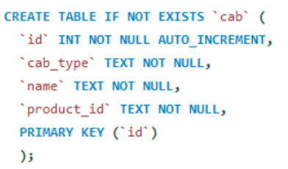

The second table, **apparent_weather**, records apparent high and low temperatures with an auto-incremented ID as the primary key.

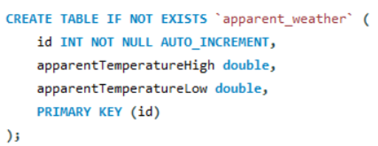

The third table, **payment**, captures payment details with an auto-incremented ID and a non-null price field.

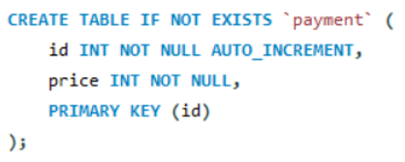

The fourth table, **weather**, stores information about temperature, wind speed, and visibility with an auto-incremented ID as the primary key

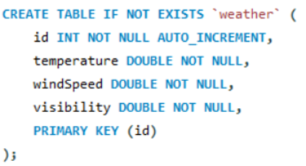

The fifth table, **ride**, captures ride details such as distance, date and time, source, and destination, with foreign keys linking to other tables for cab, apparent weather, weather, and payment information

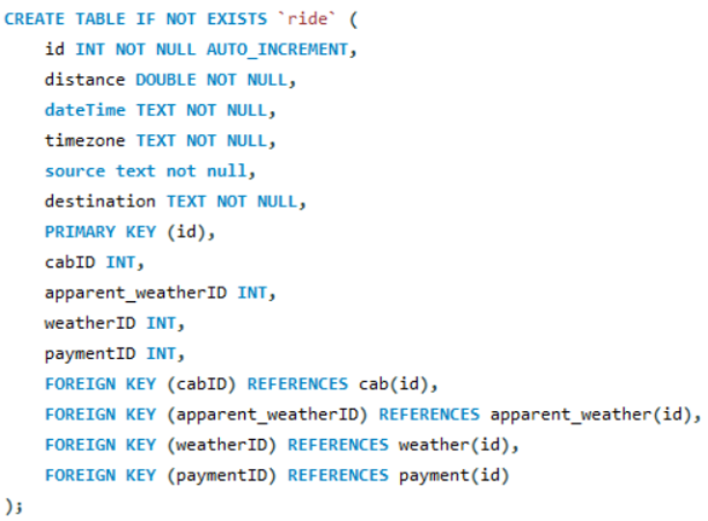

# Insert Tables

The first **INSERT INTO** statement populates the **cab** table with distinct values of cab_type, name, and product_id from the **rideshare** table where cab_type is not null.

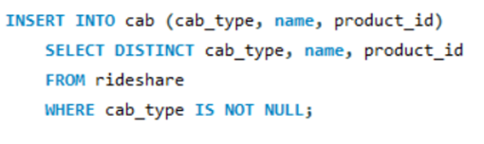

The second **INSERT INTO** statement populates the **apparent_weather** table with distinct values of apparentTemperatureHigh and apparentTemperatureLow from the **rideshare** table

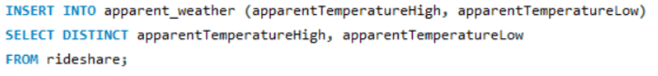

The third **INSERT INTO** statement populates the **payment** table with distinct values of price from the **rideshare** table.

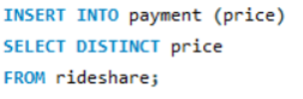

The fourth **INSERT INTO** statement populates the **weather** table with distinct values of temperature, windSpeed, and visibility from the **rideshare** table

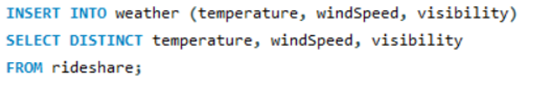

The fifth **INSERT INTO** statement populates the **ride** table by mapping values from the **rideshare** table to corresponding IDs in the **cab**, **apparent_weather**, **weather**, and **payment** tables.

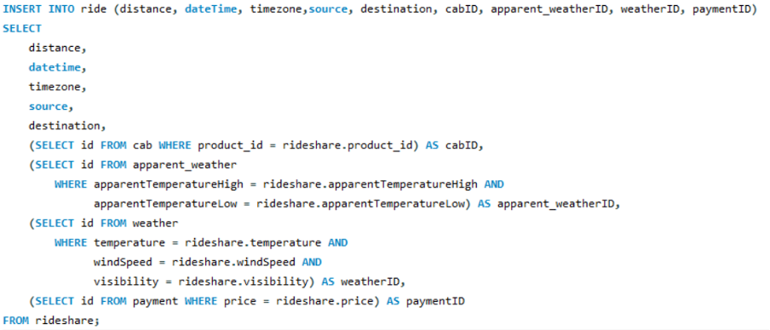

# Database Implementation

* This query will give you a result set containing all columns from the ride table and the associated columns from the payment table for rides with surge pricing. This can help you identify and analyze rides that had higher pricing due to surge conditions.

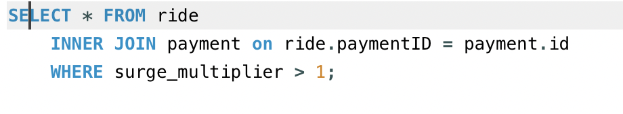

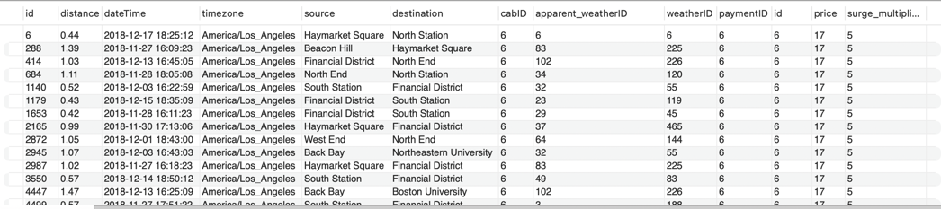

* This SQL query retrieves all columns from the ride table where the source is 'Haymarket Square', and the destination is 'North Station'. It focuses on rides that have the specified source and destination locations.

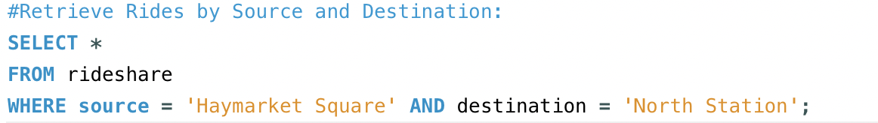

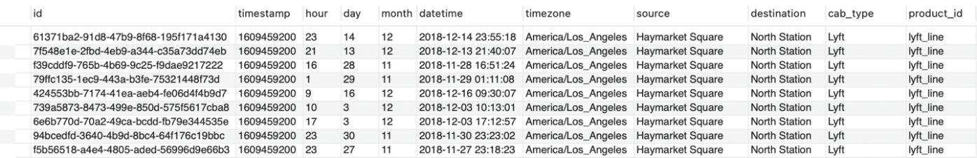

* This SQL query retrieves details about rides and associated cab information, specifically focusing on Lyft rides with the product type 'lyft_line'.



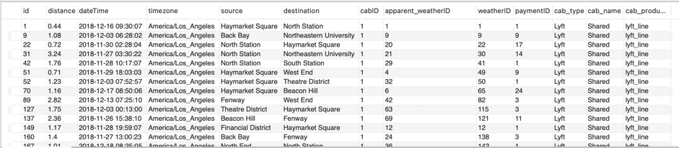

* This SQL query retrieves all columns from the ride table for rides that occurred between 8 AM and 12 PM. It uses the HOUR function to extract the hour component from the datetime column and filters the results to include only those where the hour falls between 8 and 12.

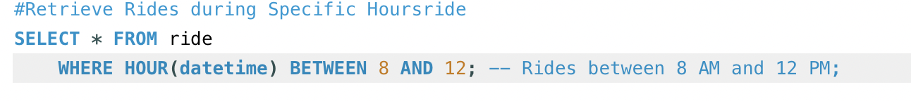

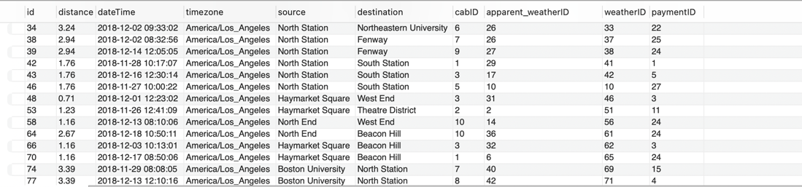

Updating Data:

* First Query update the short_summary and long summary columns for rides of type 'Uber' with new weather information.
* The second query increases the price by 20% for rides where the precipitation probability is greater than 0.5.
* The third query sets a fixed timestamp and time zone for all rides in the table.
* This increases the surge multiplier by 1.5 times for Lyft Lux Black rides that occurred during rush hours (between 4 PM and 6 PM).

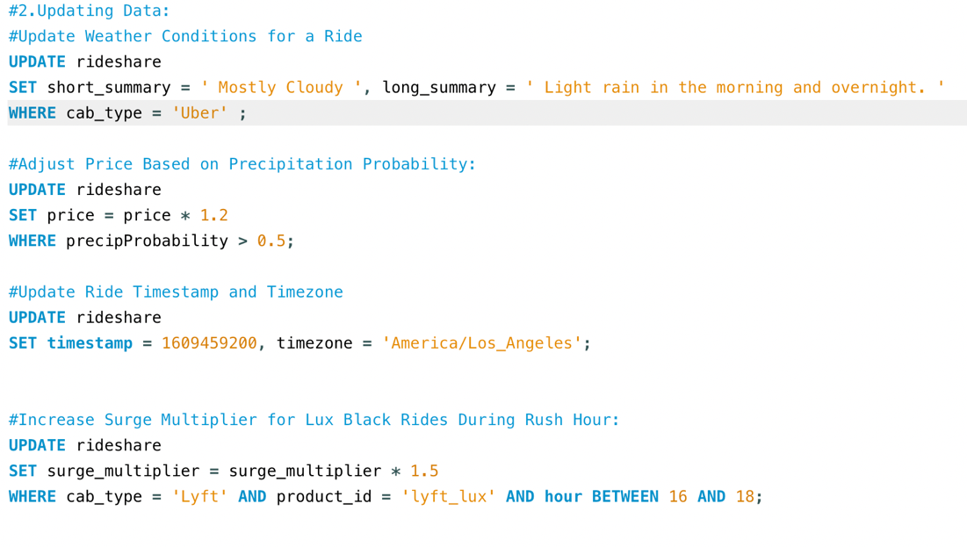

Complex Filters (Use Cases)

* This SQL query retrieves details about Lyft Premier rides during rainy weather. It selects information from the ride table, including associated cab and weather details, focusing on Lyft Premier rides (cab_type = 'Lyft' AND product_id = 'lyft_premier') where the precipitation intensity is greater than 0. Combine data from the ride, cab, and weather tables using JOIN operations based on matching IDs.

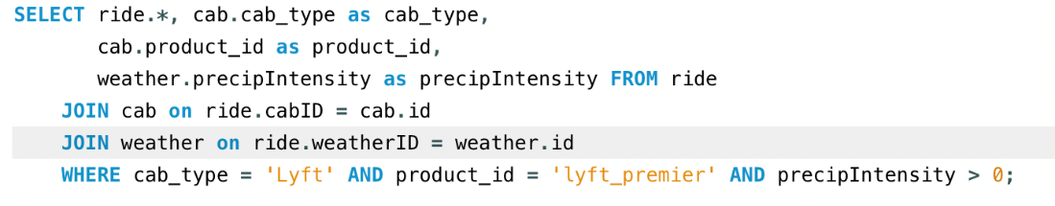

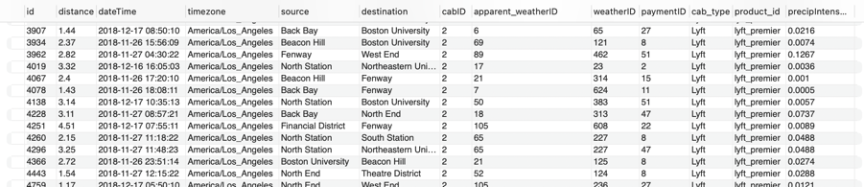

* This SQL query retrieves information about Uber Black XL rides during low temperatures. It selects details from the ride table, including associated cab and weather information, focusing on Uber Black XL rides (cab_type = 'Uber' AND product_id = '6f72dfc5-27f1-42e8-84db-ccc7a75f6969') where the temperature is less than 32 degrees.

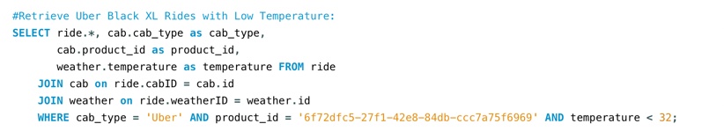

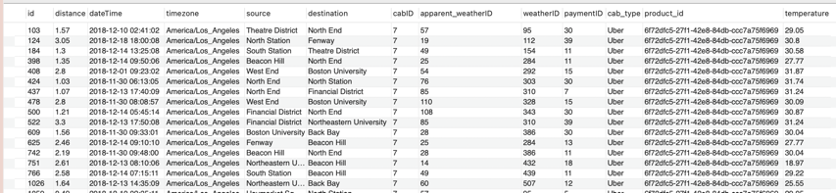

* This SQL query retrieves details about Lyft Lux rides during instances of low cloud cover. It selects information from the ride table, including associated cab and weather details, focusing on Lyft Lux rides (cab_type = 'Lyft' AND product_id = 'lyft_lux') where the cloud cover is less than 0.5.

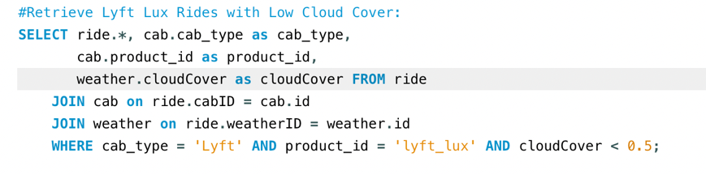

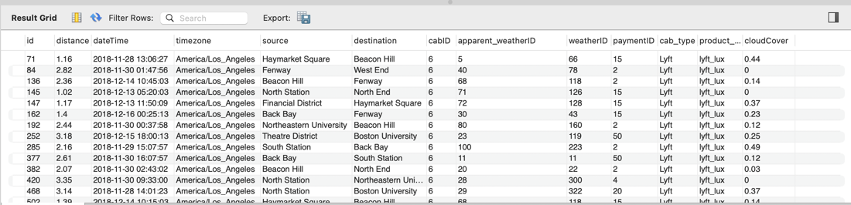

# Joins

**Creating View for further analysis:**

This SQL code creates a view named ride_joint by combining information from several tables (ride, cab, payment, weather, and apparent_weather). The view includes various details such as ride information, cab details, payment details, and weather conditions. After creating the view, it retrieves all columns from the ride_joint view.

In summary, the view combines relevant data from multiple tables into a single, easily accessible structure, and the subsequent SELECT statement fetches all columns from this view.

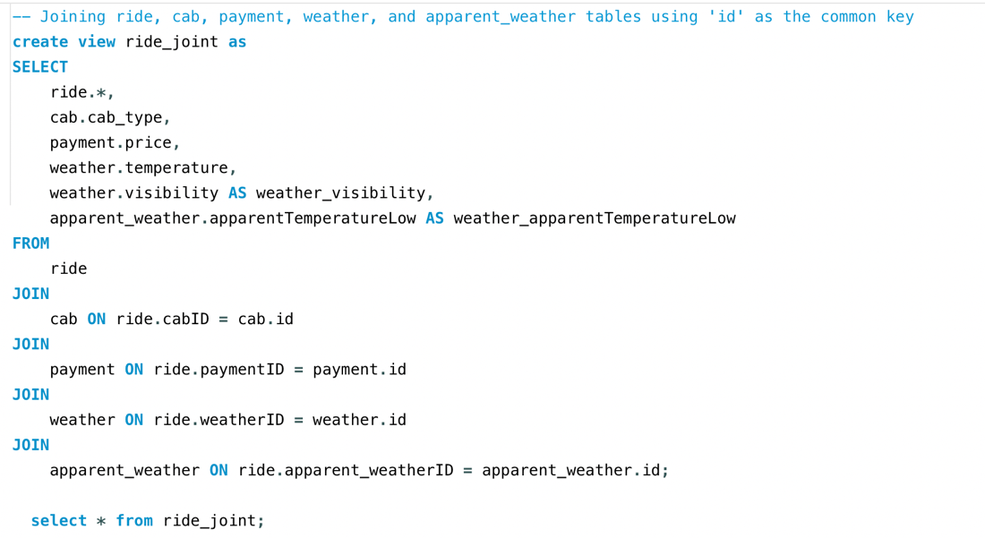

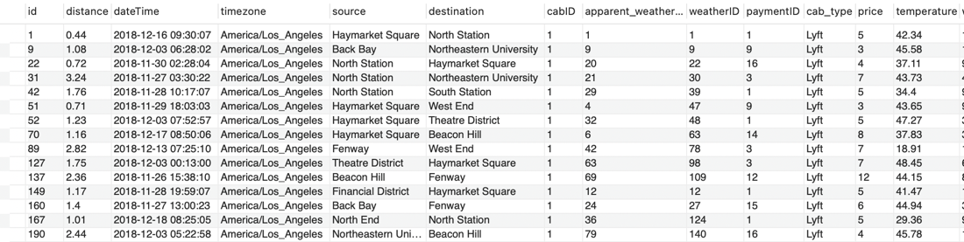

# Analytics, Reports, and Metrics

**ANALYSIS**

This query shows the avg distance a ride is covering. It retrieves the data from the ride table

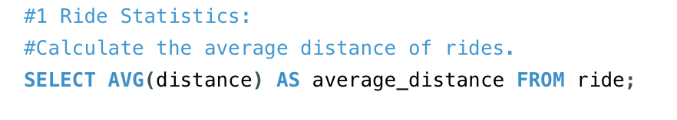

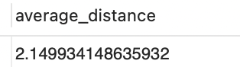

This query retrieves the combine revenue of both lyft and uber

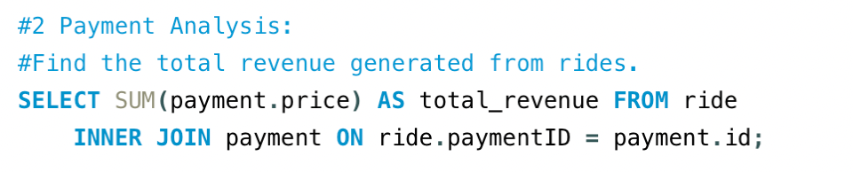

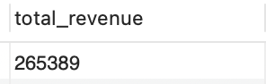

This query retrieves the avg temperature from the weather table. This provides insights into the avg temperature per ride

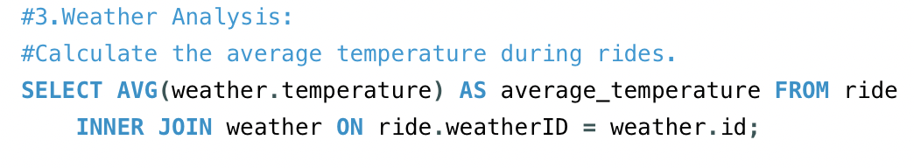

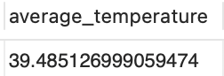

Retrieves the number of uber and lyft ride. Compare the rides taken on uber and lyft

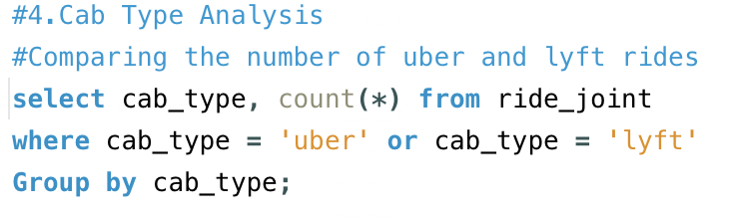

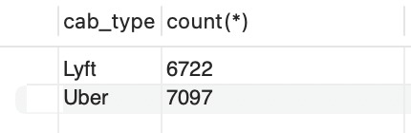

This query retrieves the rides count in each ride type for Lyft. This helps us to understand the popularity among ride types

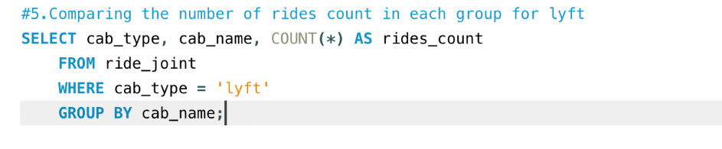

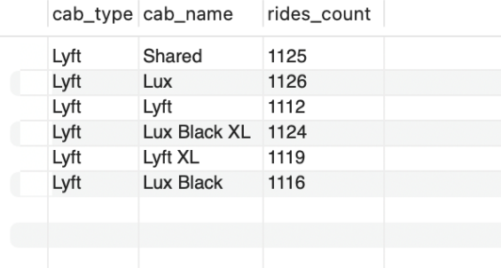

This query retrieves the rides count in each ride type for uber. This helps us to understand the popularity among ride types

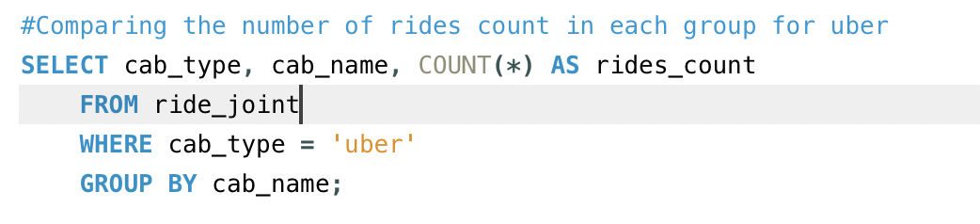

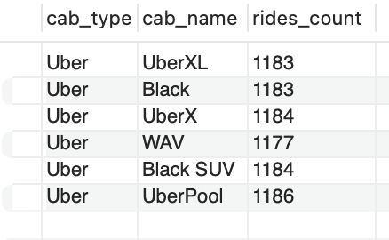

This query retrieves the revenue of lyft and uber. This provides the comparison between uber and lyft

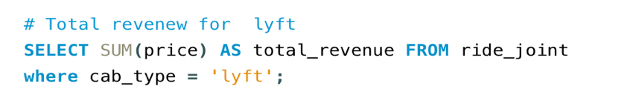

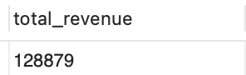

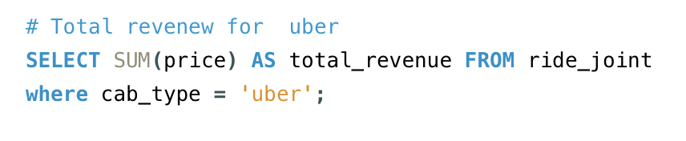

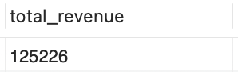

**Reports**

The query provides a count of rides for each day, grouping the results by date and presenting them in chronological order.

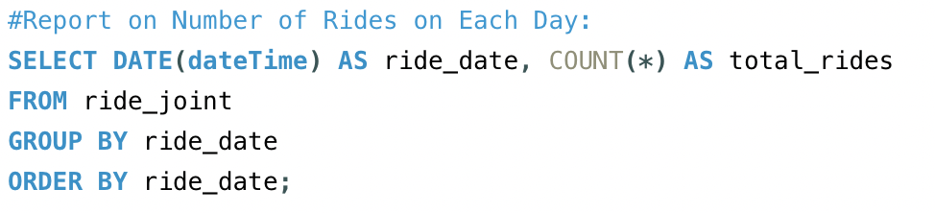

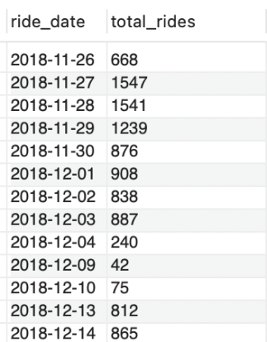

The query provides a count of rides for each hour of the day, identifying the busiest hour by sorting the results in descending order.

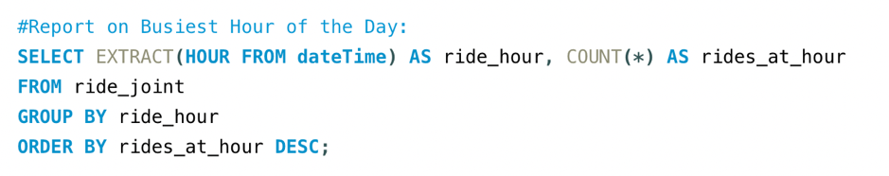

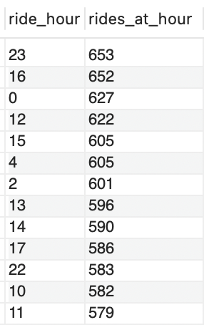

The query calculates the average price for rides with a distance exceeding 2 miles, providing a metric for longer-distance rides.

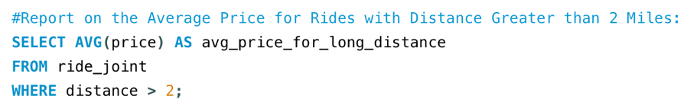

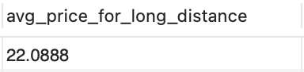

**Metrics**

The query identifies and returns the most common source and destination pair based on the highest count of rides between them.

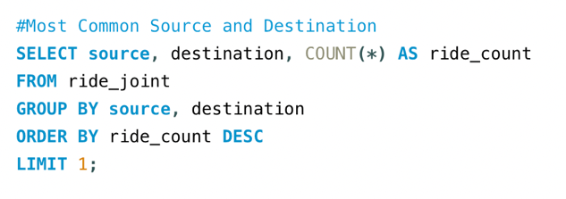

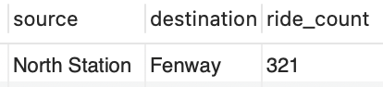

This SQL query retrieves information about the most expensive ride by selecting all columns from the ride_joint table where the price matches the maximum price in the entire dataset.

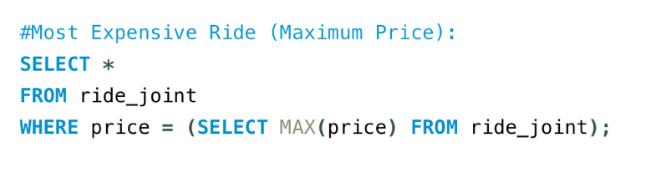



# Visualizations

The resulting scatter plot shows points representing individual rides, where the x-coordinate of each point is the distance of the ride, the y-coordinate is the price, and the points are colored based on the cab type. The transparency of the points helps in visualizing overlapping points. This plot allows you to explore the relationship between distance and price for distinct types of cabs in the rideshare dataset.

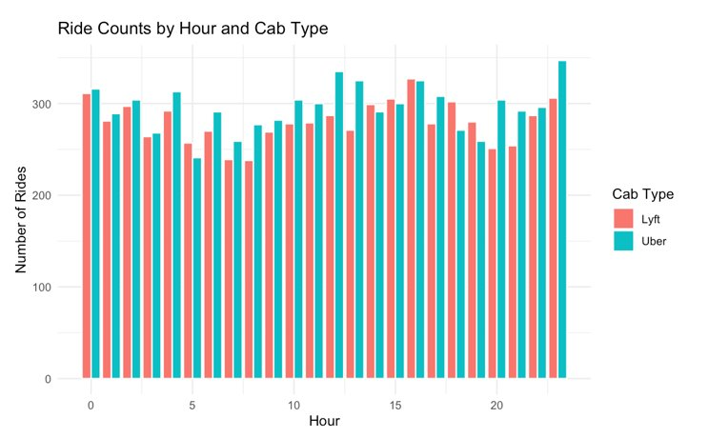

The resulting plot displays the ride counts on the y-axis, the hours of the day on the x-axis, and assorted colors for each cab type. Bars will be grouped by hour, and within each hour, there are separate bars for each cab type, allowing you to visually compare the ride counts across different hours and cab types.

# Security Concerns

**Location Data:**

* The dataset includes latitude and longitude information, potentially revealing the precise locations of passengers and drop-off points. Depending on the granularity of this information, it might be possible to infer sensitive locations, like home or work addresses.

**Timestamps:**

* Timestamps can reveal patterns of behavior, showing when and how often individuals are using the ride-sharing service. This information could be sensitive, especially if it is possible to find regular routines.

**Ride Details:**

* Details about ride types, routes, and destinations might indirectly reveal certain characteristics of users, such as their socioeconomic status, health conditions, or other preferences.

**Weather Conditions:**

* Weather data might seem innocuous, but in some cases, it could reveal sensitive information. For instance, if a user frequently takes rides during adverse weather conditions, it might indicate mobility challenges or health-related issues.

**Surge Multiplier:**

* The surge multiplier could indirectly disclose information about the demand for ride-sharing services in specific locations and times. This could be exploited for various purposes.

**Data Retention:**

* Depending on how long the data is retained, there could be concerns related to the storage of historical ride information. Longer retention periods increase the risk of unintended disclosure or unauthorized access.

**Data Access Controls:**

* Ensure that access to the dataset is restricted only to authorized personnel. Unauthorized access could lead to data breaches, privacy violations, or misuse of the information.

**Data Anonymization:**

* Consider employing data anonymization techniques to reduce the risk of re-identification. This is crucial for protecting the privacy of individuals while still allowing meaningful analysis.

**Security of Storage and Transmission:**

* The dataset should be stored securely, and any transmission of data should be encrypted to prevent unauthorized interception or access. This includes both in transit and at rest.

**Security and privacy measures**

The transportation system takes several measures to protect user data security and privacy. These measures include:

* Encryption: All sensitive data is encrypted at rest and in transit.
* Authentication and authorization: Users and drivers must authenticate and authorize themselves before accessing the system.
* Access control: Only authorized users and drivers can access specific data and features.
* Regular security audits: The system is regularly audited to identify and address any potential security vulnerabilities.
* Allow users to control their privacy settings and opt out of data collection or sharing.

# Architecture

The proposed solution architecture is designed to leverage cloud-based infrastructure to provide a scalable, reliable, and secure platform for data processing and analysis. Here are some key points to consider:

**1. Cloud-Based Hosting:**

- The solution will be hosted on a cloud platform such as AWS, Google Cloud, or Azure.

- This cloud-based approach ensures high availability, scalability, and reliability, allowing the solution to handle large volumes of data and user traffic.

**2. Data Processing and Analysis:**

- Data processing and analysis will be performed using cloud-based services, enabling efficient handling of large datasets and real-time insights generation.

- The architecture will support advanced analytics, machine learning, and AI capabilities to derive valuable insights from the data.

**3. User Accessibility:**

- The application will be accessible to users via web or mobile interfaces, providing a seamless user experience across different devices.

Users can access and interact with the data and insights from anywhere, facilitating informed decision-making.

**4. Security Measures:**

- Robust security measures will be implemented to protect sensitive data and ensure compliance with data privacy regulations.

Access controls, encryption, and other security protocols will be in place to safeguard the data's integrity and confidentiality.

**5. Scalability and Flexibility:**

- The architecture will be designed to be flexible and scalable, allowing it to adapt to changing business requirements and increasing data volumes.

- Cloud-based infrastructure enables easy scaling to accommodate growing user bases and evolving data processing needs.

**6. Integration and Interoperability:**

- The solution will support seamless integration with existing systems and tools, ensuring interoperability and data flow across different platforms.

- APIs and data connectors will facilitate data exchange and interoperability with external systems and applications.

**7. Continuous Improvement:**

- The architecture will be designed to support continuous improvement and innovation, allowing for the integration of recent technologies and capabilities as they emerge.

In summary, the proposed solution architecture leverages cloud-based infrastructure to provide a scalable, reliable, and secure platform for data processing, analysis, and user interaction. It is designed to support advanced analytics, machine learning, and AI capabilities while ensuring data security, accessibility, and flexibility to meet the needs of a growing user base.

# Conclusion

In conclusion, the development of the Transportation Analytics and Optimization System represents a significant step towards revolutionizing the efficiency and quality of transportation services in a specific region. Leveraging the rich dataset from Uber and Lyft, the project addresses the diverse needs of major user types, including riders, drivers, service providers, and data analysts.

The application caters to real-world challenges by offering services such as demand prediction, route optimization, dynamic pricing, and personalized service recommendations. By employing a freemium model, the app ensures accessibility to basic transportation analytics while providing added value through premium features for subscribers.

The integration of security measures, data anonymization, and privacy controls underscores the commitment to safeguarding user information. Furthermore, the detailed business rules, table designs, and data analysis techniques contribute to the robustness of the system.

The database implementation, encompassing table creation, data insertion, and complex queries, establishes a solid foundation for efficient data management. Security and privacy measures, including encryption, authentication, and access control, are diligently implemented to instill user confidence.

The proposed architecture, hosted on a cloud-based platform, ensures scalability, reliability, and security. With a focus on user accessibility, the application provides a seamless experience across web and mobile interfaces.

The project's commitment to continuous improvement is evident in its design for flexibility and integration capabilities, allowing for the incorporation of emerging technologies and adherence to evolving industry standards.

In summary, the Transportation Analytics and Optimization System not only addresses current transportation challenges but also sets the stage for future enhancements and innovations in the ever-evolving landscape of ride-sharing services. The comprehensive approach to data analytics, security, and user experience positions the system as an asset in the realm of modern transportation solutions.

# Recommendations

**- Enhance User Privacy:**

- Implement advanced data anonymization techniques to further protect user identities.

**- Regular Security Training:**

- Conduct periodic security training for personnel to reinforce data protection protocols.

**- Optimize Query Performance:**

- Fine-tune complex queries to improve efficiency and reduce response times.

**- Expand Data Source Integration:**

- Explore opportunities to integrate additional data sources for more comprehensive analytics.

**- User-Friendly Interfaces:**

- Continuously refine user interfaces for both analysts and end-users to ensure a seamless experience.

**- Collaborate for Innovation:**

- Foster collaboration between data analysts and business stakeholders for innovative data applications.

**- Data Retention Policy Review:**

- Regularly review and adjust data retention policies to balance historical insights with privacy concerns.

**- Explore Machine Learning Integration:**

- Investigate the integration of machine learning algorithms for predictive analytics and pattern recognition.

**- Regular System Audits:**

- Conduct routine audits to identify and address potential vulnerabilities in the system.

**- Environmental Impact Assessment:**

- Evaluate the environmental impact of cloud-based hosting and explore sustainable alternatives.

**- User Feedback Loop:**

- Establish a feedback loop with users to gather insights for continuous improvement.

**- Stay Compliant:**

- Stay informed about data privacy regulations and ensure ongoing compliance.

These recommendations aim to enhance the system's effectiveness, security, and user experience while fostering innovation and maintaining compliance with data privacy standards.

# References

SQL inner join. (n.d.). [https://www.w3schools.com/sql/sql_join_inner.asp](https://www.w3schools.com/sql/sql_join_inner.asp%20)

*Creating a view that combines data from multiple tables*. Creating a view that combines data from multiple tables with interactive SQL. (n.d.). [https://www.ibm.com/docs/en/i/7.3?topic=cuv-creating-view-that-combines-data-from-multiple-tables](https://www.ibm.com/docs/en/i/7.3?topic=cuv-creating-view-that-combines-data-from-multiple-tables%20)

Bm. (2019, October 13). *Uber and Lyft Dataset Boston, MA*. Kaggle. [https://www.kaggle.com/datasets/brllrb/uber-and-lyft-dataset-boston-ma/data](https://www.kaggle.com/datasets/brllrb/uber-and-lyft-dataset-boston-ma/data%20)

*What is an entity relationship diagram (ERD)?*. Lucidchart. (n.d.). <https://www.lucidchart.com/pages/er-diagrams#:~:text=Make%20an%20ERD-,What%20is%20an%20ER%20diagram%3F,each%20other%20within%20a%20system.>

 Gauri MahajanGauri is a SQL Server Professional and has 6+ years experience of working with global multinational consulting and technology organizations. She is very passionate about working on SQL Server topics like Azure SQL Database. (2020b, December 15). *A step-by-step walkthrough of SQL inner join*. SQL Shack - articles about database auditing, server performance, data recovery, and more. <https://www.sqlshack.com/a-step-by-step-walkthrough-of-sql-inner-join/>

Richard Peterson, & Peterson, R. (2023, October 14). *MySQL update query with example*. Guru99. <https://www.guru99.com/sql-update-query.html>  
  
Mtkachenko, mtkachenkomtkachenko   5, Ben RubinBen Rubin  6, Rick JamesRick James  137k1313 gold badges131131 silver badges224224 bronze badges, Gordon LinoffGordon Linoff   1.2m5858 gold badges652652 silver badges797797 bronze badges, & TheGameiswarTheGameiswar                    28.1k99 gold badges5858 silver badges9494 bronze badges. (1962, September 1). *Create SQL indexes for complex filtering*. Stack Overflow. <https://stackoverflow.com/questions/38552550/create-sql-indexes-for-complex-filtering>